Python – Problem Sheet 1.15

# Write a python program to check whether the entered character is an Alphabet (a-z or A-Z) or not.

Eg:

**Input: Given Character: “A”**

Output: The Given Character is an Alphabet.

**Input: Given Character: “0”**

Output: The Given Character is not an Alphabet.

## Algorithm:

1. Start
2. Declare variable “Character”
3. Read the value of variable from the user
4. If Character value is a-z or A-Z

Display “It is an alphabet”

1. Else

Display “It is not an Alphabet”

1. End

## Flowchart:

## C:\Users\user\Downloads\1.png

## Code:

chr = input("Please Enter Your Character : ")

if((chr >= 'a' and chr <= 'z') or (chr >= 'A' and chr <= 'Z')):

    print("The Given Character is an Alphabet")

else:

    print("The Given Character is not an Alphabet")

## Output:

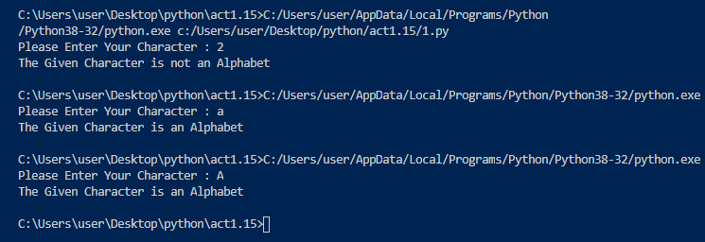

# Write a python program to check whether the input number is prime or not.

Eg:

**Input: Given number: “22”**

Output: Given number is not prime.

**Input: Given number: “13”**

Output: Given number is prime.

## Algorithm:

1. Start
2. Read the value of num from the user
3. Run a loop for I in range 2 to the given number
4. If the number is divided by I is 0

Display “Not Prime”

Break the loop

1. Else

Display “Prime”

1. End

## Flowchart:

## C:\Users\user\Downloads\2output.png

### Code:

num=int(input("Enter the number: "))

for i in range(2,num):

    if num%i==0:

        print("Not Prime.")

        break

else:

    print("Prime number.")

### Output:

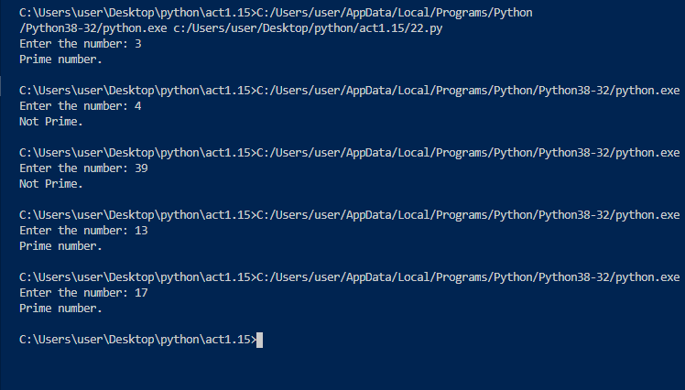

# Write a program to check whether the given year is leap year or not.

Eg:

**Input: Given year: “1992”**

Output: Given year is a Leap Year.

**Input: Given year: “1993”**

Output: Given year is not a Leap Year.

### Algorithm:

1. Start
2. Declare variable “year”
3. Read value of year from the user
4. If year % 4 == 0
5. Display “Leap Year”
6. Else
7. Display “Not a Leap Year”
8. End

### Flowchart:

### C:\Users\user\Downloads\3.png

### Code:

year=int(input("Enter the year: "))

if year%4==0:

    print("The entered year is leap year.")

else:

    print("The entered year is not a leap year")

### Output:

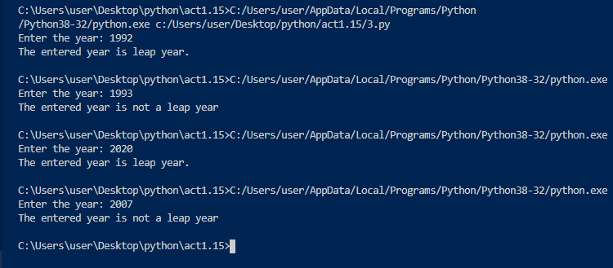

# Write a python program to get a string made of the first 7 and the last 2 characters from a given string. If the string length is less than 7, print error message like “String size is not sufficient”.

Eg:

**Input: India is our country**

Output: India iry

**Input: VIT**

Output: String size is not sufficient.

### Algorithm:

1. Start
2. Get string from the user
3. Store the length of String
4. If length of string is less than 7

Display “String size is not sufficient”

1. Else

Slice the string with length 7

Get last 2 character by negative indexing

1. Add both the strings( the one obtained in step 7th and 8th )
2. Print the sum of the Strings
3. End

### Flowchart:

### C:\Users\user\Downloads\4flow.png

### Code:

a=input("Enter a string: ")

if len(a)<7:

    print("String size is not sufficient!!!")

else:

    b=a[0:7]+a[-2]+a[-1]

    print(b)

### Output:

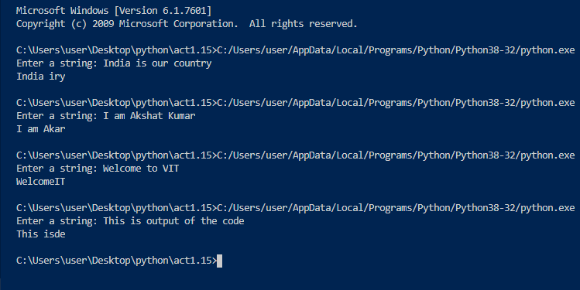

# Write a python program to get a single string from two given strings, separated by a space and swap the first two characters of each string.

Eg:

**Input: “Akshat”, “Kumar”**

Output: “Kumar Akshat”

### Algorithm:

1. Start
2. Declare variables str1 and str2
3. Read the values of variables from the user
4. Calculate result by using formula- “str2”+ “ ” + “str1”
5. Print result
6. End

### Flowchart:

### C:\Users\user\Downloads\5flow.png

### Code:

str1=input("Enter the first string: ")

str2=input("Enter the second string: ")

result=str2+" "+str1

print("RESULT: ", result)

### Output:

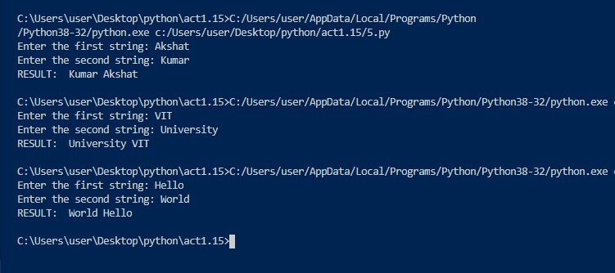

# 6. Write python program to swap two integer numbers using only two variables. Temporaryvariables should not be used.

Eg:

**Input: a=45, b=15**

Output: a=15, b=45

### Algorithm:

1. Start
2. Read the values a and b from the user
3. Sum of a and b is stored under “a”
4. Difference of a and b is stored under “b”
5. Difference of a and b is stored under “a”
6. Print the swapped values of a and b
7. End

### Flowchart:

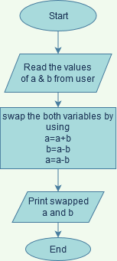

### Code:

num1=int(input("Enter the value of number 1: "))

num2=int(input("Enter the value of number 2: "))

num1=num1+num2

num2=num1-num2

num1=num1-num2

print("The value of number 1 after swapping is",num1)

print("The value of number 2 after swapping is",num2)

### Output:

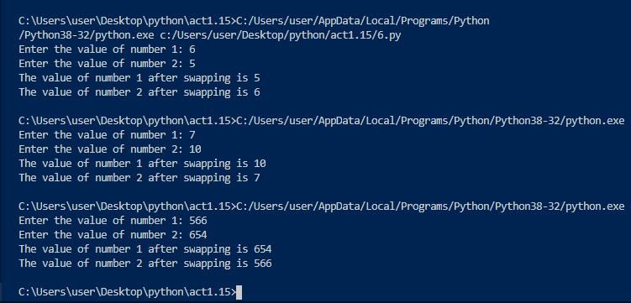

# 7. Print the following pattern using while loop.

If Number of rows =5 If Number of rows =3

Output: Output:

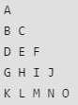 

### Algorithm:

1. Start
2. Get the value of rows(n) by the user
3. Let ascii code(a) be 65 and “i” be 0
4. Start outer while loop and run till “i” reaches the value “n”
5. Start inner while loop and run till “j” reaches the value “i”
6. For inner loop the required character is displayed according to ascii code(a) and the value of ascii code(a) is increased by 1
7. End

### Flowchart:

### C:\Users\user\Downloads\7flow.png

### Code:

n=int(input("Enter number of rows needed: "))

a=65

i=1

while i<=n:

    j=1

    while j<=i:

        print(chr(a),end=' ')

        j+=1

        a+=1

    i+=1

    print(" ")

### Output:

### 

# 8. Print the following pattern using for loop

If Number of rows =5 If Number of rows =3

Output: Output:

 

### Algorithm:

1. Start
2. Read number of rows needed from user
3. Declare a having ascii code value 65
4. Start first for loop by “i” from 0 to number of rows given by user
5. Start inner for loop from 0 to “i+1”
6. Inner for loop prints the required ascii character according to code
7. The value of character increases by 1 each time in inner loop
8. End

### Flowchart:

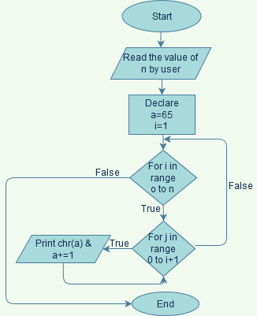

### Code:

rows=int(input("Enter number of rows required: "))

a = 65

for i in range(0,rows):

    for j in range(0,i+1):

        print(chr(a),end=' ')

        a +=1

    print("")

### Output:

### 

# 9. Write a python program to print the following pattern using while loop.

Output:

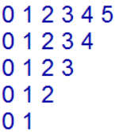

### Algorithm:

1. Start
2. Declare the value of variable “i” = 5
3. Start first while loop and run till the value of “i” is 1
4. Declare the value of variable “j” = 0
5. Start inner while loop and run till “j” value reduces to “i”
6. Print the value of “j” and end with a gap
7. Increment the value of “j” by 1
8. End the loop when “i” = 1
9. End

### Flowchart:

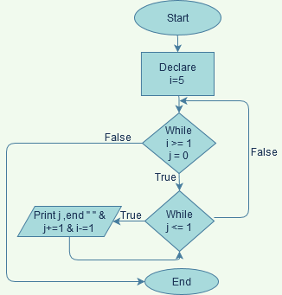

### Code:

i=5

while i >= 1:

    j=0

    while j<=i:

        print(j,end=" ")

        j+=1

    print("")

    i-=1

### Output:

### 

# 10. Write a python program to print the following pattern using for loop.

Output:



### Algorithm:

1. Start
2. Declare number of rows = 5 and variable “i”
3. Start first for loop in range 5 to 0 ( i -= 1)
4. If loop conditon is true

Start inner loop in range 0 to i+1

Else

End

1. If inner loop condition is true

Display j and end with “ ”

1. End

### Flowchart:

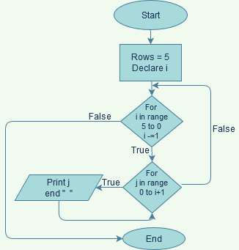

### Code:

rows=5

for i in range(rows,0,-1):

    for j in range(0,i+1):

        print(j, end=' ')

    print("\n")

### Output:

### 

THE END

This Presentation is created by Akshat Kumar [20MIS0183] under guidance of Mr. Shunmuga Perumal Sir.

THANK YOU !!!!!